**Industrial Management Assignment - 5**

Q1. Attempt all Questions:-

1. What is Resource Leveling? What are the two main approaches of resource leveling?

Answer: Resource leveling

Resource leveling is a project management technique used to examine unbalanced use of resources (usually people or equipment) over time, and for resolving over-allocations or conflicts.

Two Main approaches of Resource Leveling:

Time-constrained approach – In this case importance will be given on completing the project within a specified (imposed) date

Resource-constrained approach – In this approach, the project must be completed with limited available resources even if this means extending the project duration.

Two ways of leveling:

* + By delaying a task until the assigned resource has time to work on it.
  + By splitting a task so that part of a task is done when planned and the rest of it is done later when the assigned resource has time Resource leveling Resource allocation is used to assign the available resources in an economic way. It is the scheduling of activities and the resources required by those activities while taking into consideration both the resource availability and the project time.

Steps to make resource decisions in a rational way:

* Identify/design alternatives Identify and structure the organization’s goals

and objectives • Prioritize the objectives and sub-objectives

* Measure each alternative’s contribution to each of the lowest level sub- objectives
* Find the best combination of alternatives, subject to environmental and organizational constraint

1. What is a project? Give examples. Answer:

* A project is an interrelated set of activities that has definite starting and ending points and that result in a unique product or service
* Cuts across organizational lines – they need varied skills of different profession
* Uncertainties like new technology & external environment can change the character of the project
* Personnel, materials, facilities, etc. are temporarily assembled to accomplish a goal within a specified time frame and then disbanded
* Upon finish, a project releases lot of resources which were engaged in execution of the project.

Example of project

* Planning a wedding
* Designing and implementing a computer system
* Hosting a holiday party
* Designing and producing a brochure
* Executing an environmental clean-up of a contaminated site
* Holding a high school reunion
* Performing a series of surgeries on an accident victim

1. What are the attributes of a project? Answer:

A project:

* Has a unique purpose.
* Is temporary.
* Is developed using progressive elaboration.
* Requires resources, often from various areas.
* Should have a primary customer or sponsor.
* The project sponsor usually provides the

Direction and funding for the project.

* Involves uncertainty.

1. What do you understand by Project Management? What are the tools and techniques of Project Management?

Answer:

Project managers work with project sponsors, project teams, and other people involved in projects to meet project goals.

Program: A group of related projects managed in a coordinated way to obtain benefits and control not available from managing them individually. Program managers oversee programs and often act as bosses for project managers.

Project management: is the application of knowledge, skills, tools and techniques to project activities to meet project requirements.

Project Management Tools and Techniques: Project management tools and techniques assist project managers and their teams in various aspects of project management. Specific tools and techniques include:

Project charters, scope statements, and WBS (scope). Gantt charts, network diagrams, critical path analyses, critical chain scheduling (time).Cost estimates and earned value management (cost).

1. Define Network Analysis. What are the two forms of Network Planning? Answer: Network Analysis:- Network Analysis refers to a number of techniques for the planning and control of complex projects. The two most frequently used forms of network planning are:
2. Programme Evaluation and Review Technique (PERT)
3. Critical Path Method (CPM)

What is a Networks?

A network is a graphical diagram consisting of certain configuration of

“Arrows”

(→) and “Nodes” (.) For showing the logical sequence of various tasks to be performed to achieve the project objective.

PERT/CPM Techniques: The initial step in PERT/CPM project scheduling process is the determination of all specific activities that comprise the project and their relationships.

Example:-

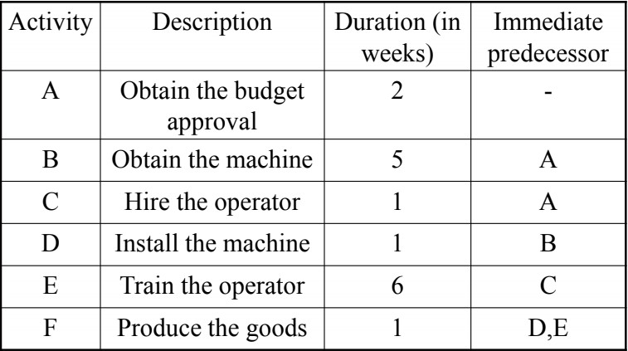

1. What is a network? Explain PERT and CPM techniques with example. Answer: - A network is a graphical diagram consisting of certain configuration of “Arrows”

(→) and “Nodes” (.) For showing the logical sequence of various tasks to be performed to achieve the project objective.

PERT/CPM Techniques: The initial step in PERT/CPM project scheduling process is the determination of all specific activities that comprise the project and their relationships.

Example:-

1. What is Project Crashing? Answer:-Project Crashing:-
   * It is common in project management that additional resources are used to either speed up some activities to get the project back on schedule or to reduce the project completion time.
   * Crashing an activity refers to the speeding up or shortening of the duration of an activity by using additional resources. These include overtime, hiring temporary staff, renting more efficient equipment, and other measures.
   * Project crashing refers to the process of shortening the duration of the project by crashing the duration of a number of activities.
   * Since it generally results in an increase of the overall project costs, the challenge faced by the project manager is to identify the activities to crash and the duration reduction for each activity such that as the project crashing is done in the least expensive manner possible.
2. What is the relationship of time and cost under crashing? Answer:-The General Relationship of Time and Cost-
   * Crashing costs increase as project duration decreases.
   * Indirect costs increase as production duration increases.
   * Reduce project length as long as crashing costs are less than indirect costs.

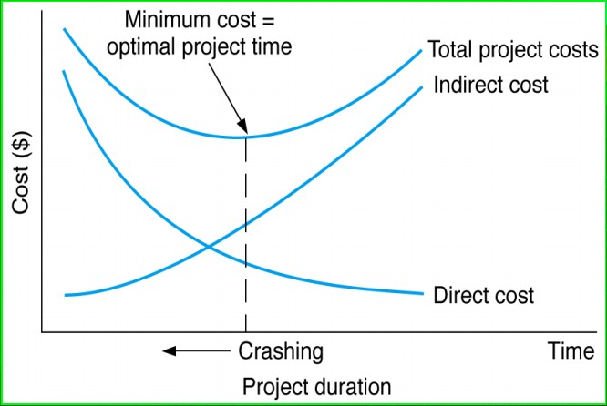

* + - The objective of crashing was to reduce the scheduled completion time to reap the results of the projects sooner.
    - However, there may be other reasons for reducing project time.
    - There also may be direct financial penalties for not completing a project on time.

1. Explain the importance of Project Management. Answer:-Importance of Project Management:-
   * Project management is important because it ensure proper expectations are set around what can be delivered, by when and for how much.
   * Effective project managers should be able to negotiate reasonable and achievable deadlines and milestones across stakeholders, terms and management.
   * The important of project management is an important topic because all organizations, be it small or large at one time or other are involved in implementing new understandings.
   * These undertakings may be diverse such as the development of a new product or services. The establishment of a new production line in a manufacturing enterprises a public relations promotions campaign or a major building programmer.
2. Explain the importance of Project Crashing. Answer:-Importance of Project Crashing:-
   * Least cost slope activity of the critical path must be dealt with first and so on.
   * If more than one critical path is generated after crashing than duration of activities on all these paths have to be curtailed.
   * If time in critical path (say A) Lowers below an alternative path (of time say x such that X>A) after crashing than crashing is done here in such a way that time in critical path is kept same as X not below X .
   * If crashing a low cost slope activity (say activity D) result in though lower a single Critical path time but project time is not lowered then.

* Select common activates or activity combinations.
* Find least cost slope among these.
  + Sometimes before critical path other path get crashed. Here the time of crashed path is the minimum limit of crashing time. Critical path are crashed down to his time limit.